ALPHA ARTS AND SCIENCE COLLEGE


AI FAQ ASSISTANT
PROJECT DOCUMENTATION

DEPARTMENT OF COMPUTER APPLICATIONS

TEAM DETAILS
T EAM LEADER: Cheran R
NM id: EF4354B2FB8DA84810D40FAAF2BA2B66
Team Members: Hariyanth S
NM Id: 6086F5CED5392D1AA124A66194F73F36
Team Members: Devapriyan k
NM id: 14C8AA7FEDAF3ACA6EF4FADE7B0E5738
Team Members: Vijay C
NM id: 76C43DE21E95B1F8A464AE5FC741A01E

Project Introduction
AI FAQ Assistant is a backend application designed to manage frequently asked questions through a RESTful API. The system provides a structured place for storing questions, answers and categories while controlling the operations that require authentication. Public users can retrieve and search FAQ information, while authenticated users can create FAQs and modify or delete the FAQs they own.
The project is implemented using Node.js and Express.js. MongoDB is used for persistent storage and Mongoose provides the object data modelling layer. User authentication is handled using JSON Web Tokens, and passwords are protected with bcrypt hashing. A small Gemini integration provides AI-generated answers and draft FAQ content when those protected endpoints are requested.
The AI FAQ Assistant is a robust, secure, and intelligent REST API platform designed to streamline FAQ creation, user authentication, and AI-powered content management. Built with Node.js and Express.js, the application utilizes MongoDB as its primary data store along with Mongoose ODM for elegant data modeling and schema validation.
Security is central to the architecture, implementing JWT (JSON Web Tokens) for stateless user sessions and route guarding alongside bcrypt for strong password encryption. The backend handles intensive operations like automated FAQ generation, semantic search queries, and dynamic context parsing. It also features robust centralized error handling and response status sanitization to prevent unhandled database leakage and ensure operational durability.

Purpose
The main purpose is to make FAQ information easier to maintain and retrieve through a simple API. Instead of keeping questions and answers as unstructured documents, the system stores each FAQ as a database record with a category and creator reference. This makes the content searchable and allows modification rights to be checked at the API level.

Key Objectives
- Centralize FAQ information in MongoDB.
- Provide registration and login for users.
- Secure private endpoints with JWT authentication.
- Allow authenticated users to create, update and delete their own FAQs.
- Provide public FAQ retrieval and keyword search.
- Validate incoming request data.
- Handle database and application errors consistently.
- Provide limited AI assistance for answering questions and drafting FAQs.

Problem Statement and Proposed System

Problem Statement
Frequently asked questions are useful only when they are easy to maintain and retrieve. A manual FAQ process can make it difficult to identify existing information, update outdated answers, or control who can change shared content. Repeated questions may also require a support person to prepare similar answers again and again.
The project addresses these issues with an API-driven FAQ repository. A user can authenticate once and then use the protected operations available to that account. FAQ records contain their own question, answer, category and creator reference. Public read and search operations make the stored information available without exposing modification operations.

Proposed System
The proposed system uses Express.js as the application layer. Routes receive HTTP requests and pass them through validation and authentication middleware where required. Controllers contain the application logic. Mongoose models communicate with MongoDB. The AI service is separated from the controllers so that the Gemini integration remains a supporting service rather than being mixed with the FAQ database logic.

Scope of the Implemented System
Area | Implemented Function
Authentication | Registration, login, JWT token verification and profile retrieval
FAQ | Create, read, update and delete operations
Search | Case-insensitive keyword/regular-expression search
Ownership | Creator check for FAQ update and delete
Validation | Request validation and category validation
Database | MongoDB through Mongoose
Errors | Centralized error middleware
AI | Protected answer and FAQ generation endpoints

System Requirements

Functional Requirements
- The system shall allow a new user to register with name, email and password.
- The system shall prevent duplicate user email registration.
- The system shall authenticate users with email and password.
- The system shall issue a JWT after successful login.
- The system shall allow an authenticated user to retrieve the user's profile.
- The system shall allow an authenticated user to create an FAQ.
- The system shall allow public retrieval of FAQ records.
- The system shall allow a user to update or delete an FAQ created by that user.
- The system shall provide FAQ search using a query parameter.
- The system shall validate supported FAQ categories.
- The system shall provide protected AI answer and AI FAQ generation operations.

Non-Functional Requirements
Requirement | Application
Security | bcrypt password hashing and JWT protected routes
Maintainability | Separated routes, controllers, models, middleware and services
Reliability | Centralized error handling and database error processing
Performance | Direct MongoDB queries and lightweight Express routing
Scalability | Modular API structure can be extended with additional modules
Configuration | Environment variables for database, token and AI configuration
Usability | Simple REST endpoints and JSON responses

Software Environment
Software | Purpose
Node.js | Runtime
Express.js | Web framework
MongoDB | Database
Mongoose | ODM
Postman | API testing
Visual Studio Code | Development environment

Technology and Architecture

Technology Stack
Technology | Role in the Project
Node.js | Runs the JavaScript backend.
Express.js | Provides HTTP routing and middleware.
MongoDB | Stores user and FAQ documents.
Mongoose | Defines schemas and performs database operations.
JWT | Provides stateless authentication.
bcrypt | Hashes and compares passwords.
dotenv | Loads environment configuration.
CORS | Handles cross-origin requests.
Google Gemini SDK | Supports the two AI operations.

Architecture
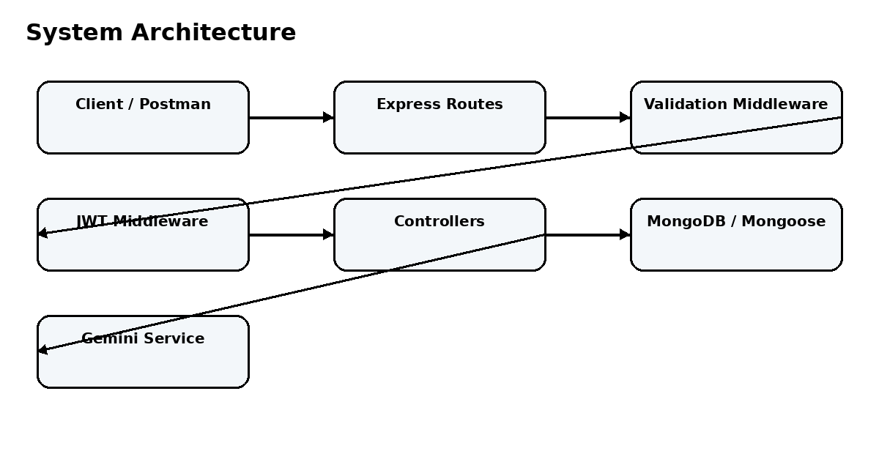
Figure 1: High-level system architecture
The architecture separates transport, security, validation, business logic and data access. This separation makes the project easier to understand and modify. The Gemini service is connected only to the AI controller path.

Application Flow
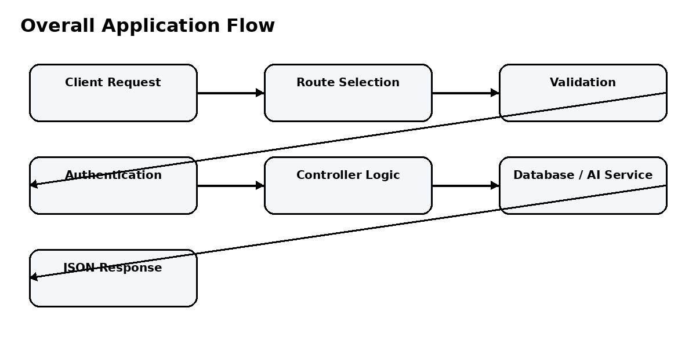
Figure 2: Overall request flow
A request first reaches the Express application. The route determines the required controller and middleware. Validation checks required input. Protected endpoints then verify the JWT. The controller performs the requested operation using either MongoDB through Mongoose or the Gemini service. The final result is returned as JSON.

Public and Protected Operations
Public | Protected
GET / | GET /api/auth/profile
POST /api/auth/register | POST /api/faqs
POST /api/auth/login | PUT /api/faqs/:id
GET /api/faqs | DELETE /api/faqs/:id
GET /api/faqs/:id | POST /api/ai/answer
GET /api/faqs/search?q=... | POST /api/ai/generate-faq

User Registration and Authentication

Registration
Registration accepts name, email and password. The validation middleware checks that the required values exist, that the email has a valid format, and that the password satisfies the minimum length requirement. The controller checks for an existing account before creating a new User document.
POST /api/auth/register
{
"name": "Priya Sharma",
"email": "priya@example.com",
"password": "securepassword123"
}
The User model hashes the password before saving. The response returns the created user information and a JWT token.

Login
Login receives an email and password. The controller finds the matching user and calls the model's password comparison method. When the credentials are valid, a JWT is generated with the user's database ID and a 30-day expiration.
POST /api/auth/login
{
"email": "priya@example.com",
"password": "securepassword123"
}

Protected Request
Authorization: Bearer <JWT_TOKEN>

Authentication and Security

JWT Authentication Flow
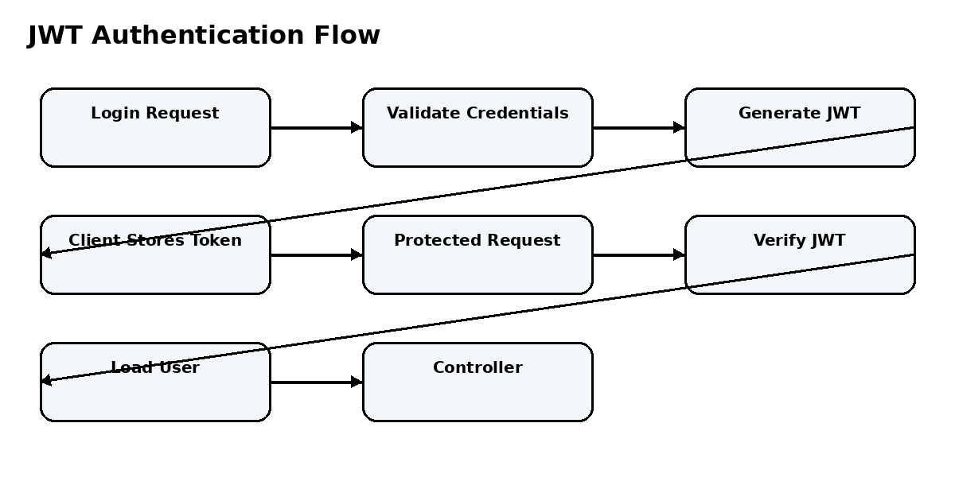
Figure 3: JWT authentication flow
The authentication middleware reads the Authorization header and expects a Bearer token. The token is verified using the configured JWT secret. The user ID stored in the token is used to retrieve the user, excluding the password field. The authenticated user is attached to req.user.

Security Measures
- Passwords are not stored as plain text; bcrypt is used for hashing.
- JWT is required for protected API operations.
- User passwords are excluded when the authenticated user is loaded.
- FAQ write operations verify the creator's ownership.
- Environment variables are used for secrets and database configuration.
- Validation is performed before controller process requests.
- Centralized error handling keeps error responses consistent.

Database Design

User Collection

Field | Type | Purpose
_id | ObjectId | User identifier
name | String | User name
email | String | Unique login email
password | String | Bcrypt hash
createdAt | Date | Creation time
updatedAt | Date | Last update time

FAQ Collection
Field | Type | Purpose
_id | ObjectId | FAQ identifier
question | String | FAQ question
answer | String | FAQ answer
category | String | FAQ classification
createdBy | ObjectId | Reference to User
createdAt | Date | Creation time
updatedAt | Date | Last update time

Entity Relationship
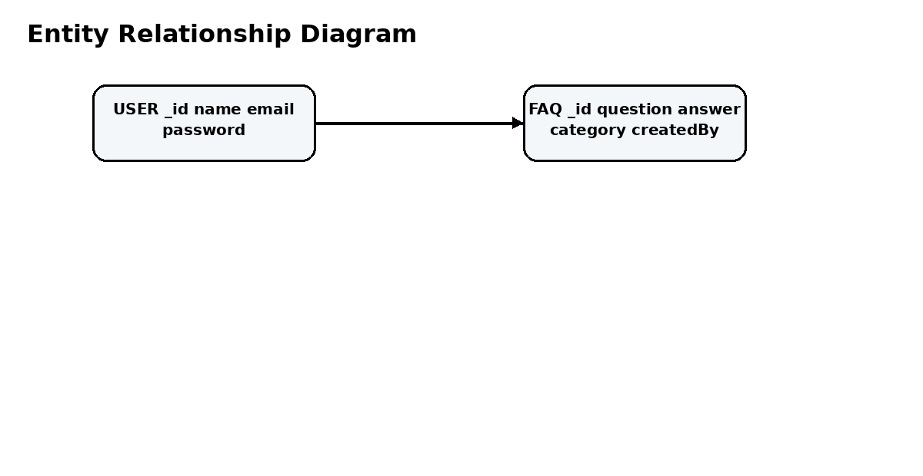
Figure 4: User to FAQ relationship
The relationship is one-to-many: one user can create multiple FAQs, while every FAQ contains one creator reference. The createdBy field is used during update and delete operations to verify ownership.

9. FAQ Management

Create FAQ
The create endpoint is protected. The request must contain a question, answer and category. The validation middleware checks the required fields and the allowed category values. The controller adds the authenticated user's ID as createdBy before saving the document.
POST /api/faqs
{
"question": "What is Express.js?",
"answer": "Express.js is a web framework for Node.js.",
"category": "Technology"
}

Read FAQs
The public FAQ endpoints return stored FAQ information. The list operation retrieves FAQ records and orders them by creation time. A single FAQ can be retrieved using its MongoDB ObjectId.

Update FAQ
The update endpoint requires authentication. After locating the FAQ, the controller checks whether createdBy matches the authenticated user's ID. Only the creator is allowed to modify the record.

Delete FAQ
Delete follows the same ownership principle. The record is located first, the creator is compared with the authenticated user, and the record is removed only when the ownership condition is satisfied.

FAQ Categories and Search

Supported Categories
Category | Use
Technology | Technology and software questions
Education | Education-related questions
Health | Health-related questions
Banking | Banking and financial-service questions
General | General-purpose questions

Category Validation
The FAQ validation middleware checks the category against the supported list. An unsupported value is rejected before the controller creates or updates the FAQ.
const validCategories = [
'Technology',
'Education',
'Health',
'Banking',
'General'
];

Search
FAQ search is implemented as a case-insensitive regular-expression search. The query parameter is compared against the question, answer and category fields. This implementation is keyword-based and should not be described as semantic or vector search.
GET /api/faqs/search?q=MongoDB
For example, a query containing MongoDB can match an FAQ question, answer, or category when the stored text contains the requested term. Search results are returned through the FAQ API in JSON format.

Validation and Middleware

Validation Middleware
Validator | Purpose
Registration | Checks name, email and password.
Login | Checks email and password.
FAQ | Checks question, answer and category.
AI Answer | Checks that a question is supplied.
AI FAQ | Checks that a topic is supplied.

Authentication Middleware
Authentication middleware protects routes that require a logged-in user. It verifies the token, obtains the user, and makes the authenticated user available to downstream controller code.

Error Middleware
The centralized error handler processes duplicate-key errors, Mongoose validation errors, invalid ObjectId/cast errors, explicit application status errors and unexpected server errors. The goal is to return a predictable JSON response rather than repeating error formatting inside every controller.

Middleware Flow
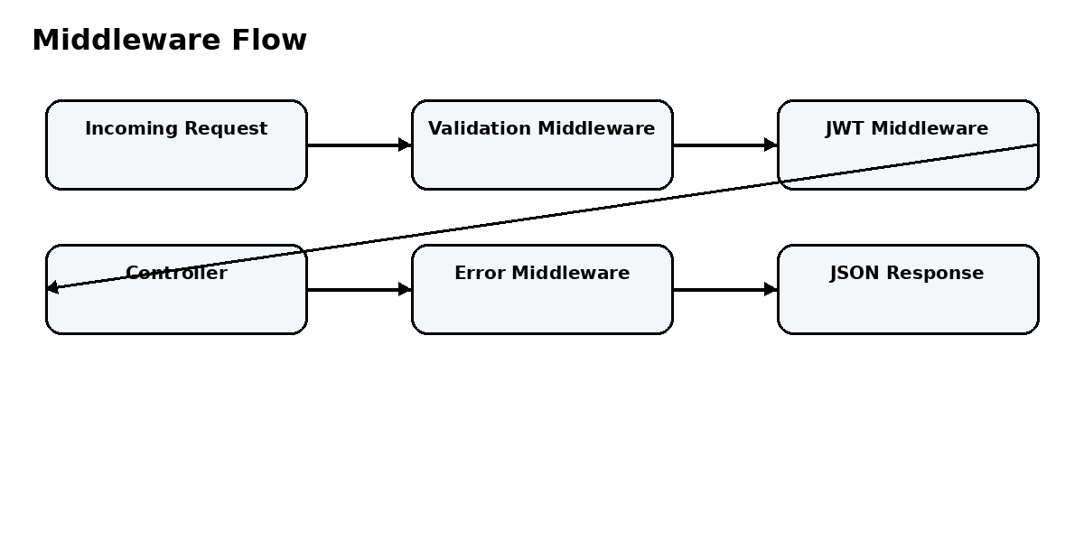
Figure 5: Validation, authentication and error flow

API Structure
Method | Endpoint | Access | Function
GET | / | Public | API status/health response
POST | /api/auth/register | Public | Register user
POST | /api/auth/login | Public | Login and return token
GET | /api/auth/profile | Protected | Return authenticated profile
POST | /api/faqs | Protected | Create FAQ
GET | /api/faqs | Public | List FAQs
GET | /api/faqs/:id | Public | Get one FAQ
PUT | /api/faqs/:id | Protected | Update owned FAQ
DELETE | /api/faqs/:id | Protected | Delete owned FAQ
GET | /api/faqs/search?q=... | Public | Search FAQs
POST | /api/ai/answer | Protected | Generate AI answer
POST | /api/ai/generate-faq | Protected | Generate AI FAQ pair

Request and Response Format
The API uses JSON request bodies for registration, login, FAQ creation/update and AI operations. Responses use JSON and generally contain a success indicator together with a message or data object.
{
"success": true,
"data": {}
}
{
"success": false,
"message": "Error message"
}

HTTP Status Codes
Code | Use
200 | Successful read/update/delete/AI operation
201 | Successful creation
400 | Invalid request or validation/database constraint error
401 | Authentication failure
403 | Ownership or permission rejection
404 | Resource or route not found
500 | Unexpected server error

Backend Module Design

Configuration Module
The database configuration module establishes the MongoDB connection through Mongoose. The connection string is read from MONGO_URI, with a local MongoDB fallback in the supplied implementation.

Model Module
The User model manages account fields, password hashing and password comparison. The FAQ model defines FAQ fields, category restrictions, creator reference and timestamps.

Route Module
Route files map URL paths and HTTP methods to validation middleware, authentication middleware where required, and controller functions. This keeps endpoint definitions separate from business logic.

Controller Module
Controllers receive validated requests and implement application behaviour. The authentication controller handles registration, login and profile retrieval. The FAQ controller handles CRUD and search. The AI controller delegates AI operations to the Gemini service.

Service Module
The Gemini service contains the external AI communication logic. This prevents provider-specific code from being spread across route files and keeps AI configuration in one place.

Utility Module
The helper module provides reusable JWT token generation. Reusable helpers reduce duplication and keep small cross-cutting functions separate from controllers.

Gemini AI Integration

Gemini is intentionally a small supporting part of the project. The main system is the FAQ management backend. Gemini is used only when a protected AI endpoint is called.

AI Answer

The AI answer endpoint receives a question. After validation and authentication, the controller sends the question to the Gemini service. The service creates a prompt requesting a concise answer and returns the generated text.
POST /api/ai/answer
{
"question": "What is MongoDB?"
}

AI FAQ Generation

The AI FAQ generation endpoint receives a topic. The Gemini service requests a question-and-answer pair in a structured JSON format. The controller returns the generated result to the client.
POST /api/ai/generate-faq
{
"topic": "MongoDB"
}
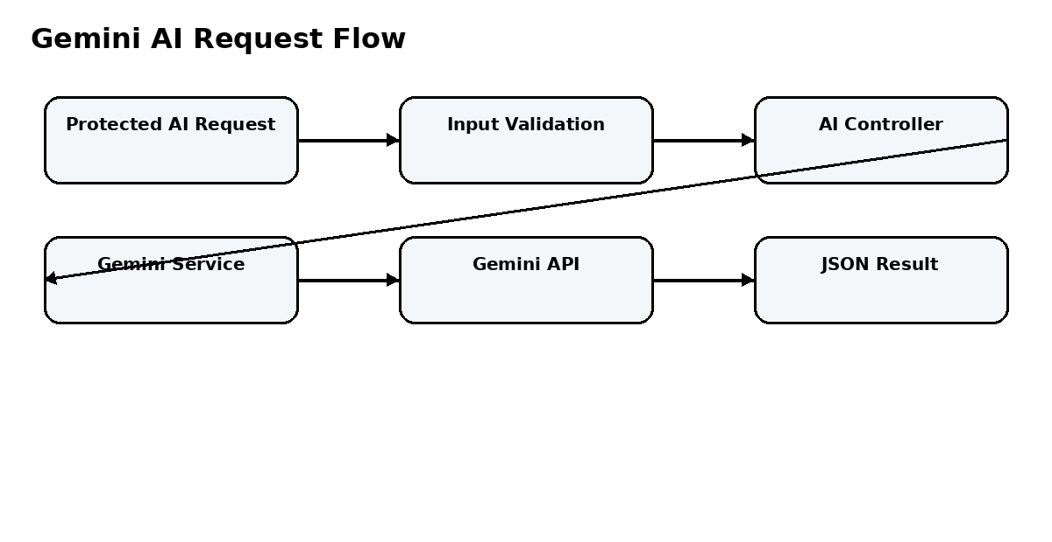
Figure 6: Limited Gemini AI flow
The generated FAQ is not automatically inserted into MongoDB by the AI endpoint. If the generated content is to become a permanent FAQ, it can be reviewed and then submitted through the normal FAQ creation process.

Database Connection and Configuration

Environment Configuration
The application uses environment variables for values that should not be embedded directly into source code. These include the MongoDB connection string, JWT secret, server port and Gemini API key.
MONGO_URI=mongodb://127.0.0.1:27017/ai_faq_assistant
PORT=5000
JWT_SECRET=<secure-secret>
GEMINI_API_KEY=<api-key>
The actual secret values should be kept outside the documentation and source repository.

Server Startup
The server startup sequence connects to MongoDB before starting the HTTP server. This ensures that the application attempts to establish its database dependency during startup. The server uses the configured port or a default port when no port value is supplied.

Express Application Configuration
app.use(cors());
app.use(express.json());
app.use(express.urlencoded({extended:false}));
app.use('/api/auth', authRoutes);
app.use('/api/faqs', faqRoutes);
app.use('/api/ai', aiRoutes);
app.use(errorHandler);

Data Flow
A normal FAQ request therefore travels through Express, route middleware, a controller, Mongoose and MongoDB, and then returns as a JSON response. An AI request follows the same API entry process but uses the Gemini service instead of MongoDB for the generated response.

Testing and API Verification

Testing Approach
The supplied project includes an integration test script and a Postman collection. The tests cover the main authentication and FAQ workflow and include invalid input cases. Postman can be used for interactive verification of every endpoint.
Test Area | Expected Behaviour
Health check | API returns successful status information.
Registration | New user is created successfully.
Duplicate registration | Duplicate email is rejected.
Login | Valid credentials return a JWT.
Invalid login | Invalid credentials are rejected.
Profile without token | Protected request returns authentication error.
Profile with token | Authenticated user profile is returned.
FAQ creation | Valid FAQ is created.
FAQ retrieval | FAQ list and individual FAQ can be read.
Invalid FAQ ID | Invalid identifier is rejected.
FAQ search | Matching records are returned.
FAQ update | Creator can update the FAQ.
FAQ delete | Creator can delete the FAQ.
AI answer | Protected AI request is validated and processed.
AI FAQ | Protected topic request is validated and processed.

Postman Test Sequence
- Register a test user.
- Login using the registered credentials.
- Copy or save the JWT token for protected requests.
- Call the profile endpoint.
- Create an FAQ.
- Read the FAQ list and individual FAQ.
- Search the FAQ using a keyword.
- Update the FAQ as its creator.
- Delete the FAQ.
- Test the protected AI endpoints.

Advantages, Limitations and Future Scope

Advantages
- Modular backend structure.
- Centralized FAQ storage.
- JWT-based protected operations.
- Bcrypt password protection.
- Creator-based FAQ ownership.
- Public FAQ retrieval and search.
- Reusable validation and error middleware.
- Optional AI assistance.
- Clear REST API endpoint structure.
- Search is keyword/regular-expression based rather than semantic/vector search.
- The supplied User model does not contain a role field, so role-based administration is not part of the implemented model.
- AI-generated FAQ content is returned and is not automatically stored.
- AI functions depend on a valid Gemini API configuration.
- The supplied implementation is backend/API focused rather than a complete frontend application.

Limitations

Future Enhancements
- Add a frontend dashboard for FAQ browsing and management.
- Add role-based administration if required.
- Add pagination for large FAQ collections.
- Add semantic or vector search.
- Add FAQ approval before publishing AI-generated content.
- Add audit history for FAQ modifications.
- Add stronger rate limiting and API abuse protection.
- Expand automated unit and integration testing.

Conclusion
AI FAQ Assistant provides a complete backend foundation for managing FAQ information through a REST API. The system combines authentication, validation, database persistence, ownership control, search, error handling and limited AI assistance in a modular architecture. Its primary purpose remains structured FAQ management, while Gemini adds an optional capability for generating answers and draft FAQ content.

Project Summary
Component | Implemented Role
Express API | Receives and routes HTTP requests
JWT + bcrypt | Authentication and password security
MongoDB + Mongoose | Persistent user and FAQ storage
FAQ module | CRUD and search functionality
Middleware | Validation, authentication and error processing
Gemini service | Limited AI answer and FAQ generation
Postman / tests | API verification

OUTPUT
Running the API Application
• Install Postman or Thunder Client (VS Code extension).
• Start the backend development server environment parameters:
npm run dev
API Testing Specification Demo
To verify operational structural integrity via execution endpoints, map endpoints using the configurations below:
1. Identity Onboarding Path Registration
• Route: POST /api/auth/register
• Access: Public
• Payload Request Body JSON:
• Route: POST /api/auth/login
• Access: Public
• Payload Request Body JSON:
Keyword Resource Entity Fetching (Search)
• Route: POST /api/ai/generate-faq
• Access: Private (Bearer <JWT Token>)
• Payload Request Body JSON:
• Route: POST /api/ai/answer
• Access: Private (Bearer <JWT Token>)
• Payload Request Body JSON:
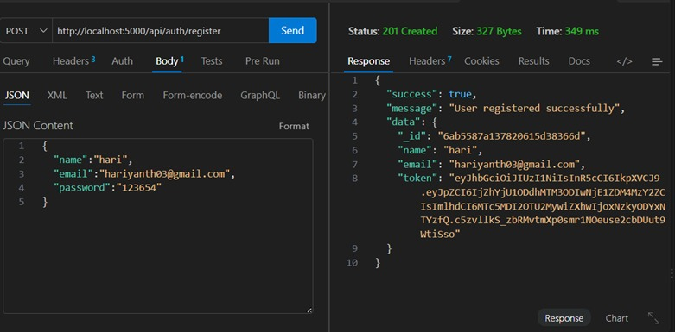
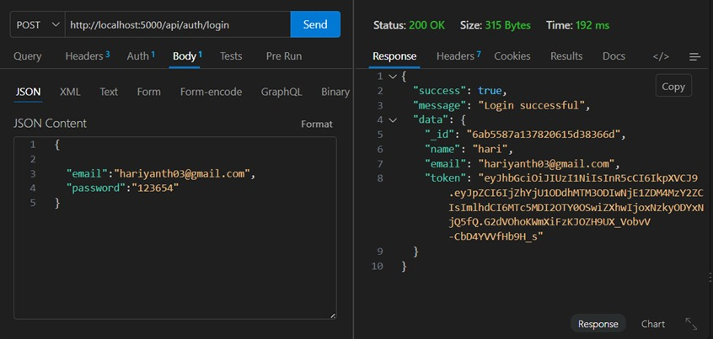
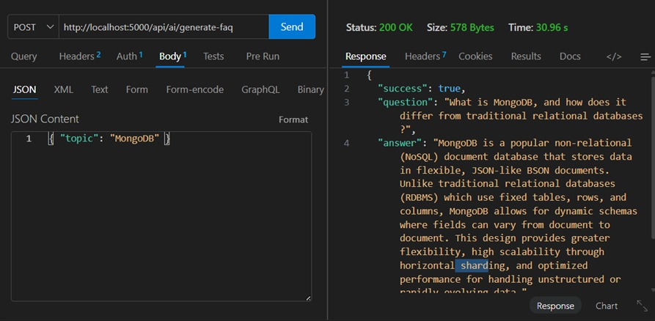
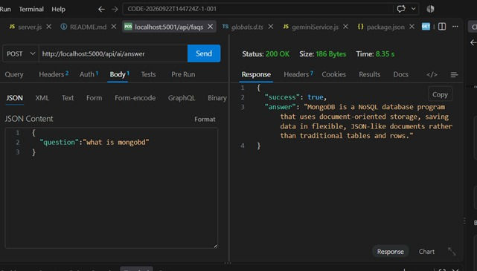

DRIVE LINK
https://drive.google.com/drive/folders/1sGzvgIVSAKN_sAmkBUgpKB6WODglItXx?usp=sharing
GITHUB LINK
https://github.com/hariyanthbca2024-sys/Ai-FAQ-Assistant-API

